NORTON

GOAL
Our Vision is to protect and empower people to live their digital lives safely.
Our Mission is to build a comprehensive and easy-to-use integrated portfolio that prevents, detects, and responds to cyberthreats and cybercrimes in today’s digital world.
COMPETITIVE ADVANTAGE
Norton’s future revenue growth will be driven by its growing customer-base and accelerated product innovation initiative.
The company’s proposed Avast acquisition will drive both revenue and profitability growth since Avast is a strong cybersecurity player.
For long-term growth-oriented investors, Norton is an excellent company to own with Avast as a part of it.

Norton operates in a highly competitive market. Its competitors include McAfee (MCFE), Microsoft (MSFT), Trend Micro (OTCPK:TMICY), Equifax (EFX), Experian (OTCQX:EXPGF), and TransUnion (TRU). Norton competes with these companies on the basis of product offerings, integration across key cyber-safety categories, and customer service.

Norton's primary competitive advantage is that it strives to release new technologies and enhancements to existing technologies at an accelerated pace. In addition, apart from developing its own in-house technologies, it acquires new technologies as and when needed. In this way, the company addresses today's cyber threat landscape which is larger and more complicated than ever before. The company finds synergies to integrate current and future technology acquisitions properly, so that it can quickly respond to consumer demands and behaviors, which are rapidly changing and driving more activities online. In this way, the company bolsters its long-term revenue growth. The company's another competitive advantage is that it has significant expertise in digital marketing, capitalizing on which the company grows its customer-base by beating competitors' marketing strategy. The company's continued investment to further improve its digital marketing capability will result in long-term revenue growth.
RISKS
Norton's primary risk factor is its indebtedness. Although the company generates significant cash flow to pay off the debt, its cash flow level is fluctuating, which is worrisome. The company's debt-load could prevent it to fund revenue growth in the long term. If the company fails to pay off its debt rapidly, its revenue growth and profitability could be negatively impacted.

The company's future success depends on its ability to address the threats consumers are facing every day. For this, the company has to incur significant research and development expenses on a continuous basis. However, if after incurring such expenses, the company fails to achieve the desired benefits from these investments, its operating results may be adversely affected.
PORTER STRATEGY
Not a low cost strategy.
Differentiate a lot.

SWOT ANALYSIS
Gen Digital Inc. (Gen Digital or "the company"), formerly known as NortenLifeLock Inc, is involved in offering security, storage and systems management solutions to protect against attacks across endpoints, cloud and infrastructure. Broad portfolio of robust software and services, revenue growth, and strong research and development capabilities are the company's major strengths, even as increase in liabilities remain causes for concern. Cloud computing market, positive outlook for global IT services, and global cybersecurity market are likely to offer growth opportunities to the company. However, increasing software piracy, complex and challenging markets, and technology changes could affect its business operations.
Strength
- Strong research and development capabilities strengthen competitiveness
- Broad portfolio of robust software and services provides growth opportunities in new as well as existing markets
- Revenue growth enables the company to pursue expansion plans
Weakness
- Increase in liabilities
Opportunity
- Positive outlook for global cybersecurity market
- Positive outlook for global IT services
- Positive outlook for cloud computing market
Threat
- Complex and challenging markets
- Technology changes
- Increase in software piracy

Board Leadership Structure As set forth in our Corporate Governance Guidelines, it is our general policy that the Chair of the Board should be independent. In the event that the Chair leaves the Board or ceases to be independent, the Board must appoint a new independent Chair from among the remaining independent directors within a reasonable amount of time. Currently, the roles of Chief Executive Officer and Chair are separate. Frank Dangeard currently serves as Chair of the Board. The Board believes that separating the roles of Chief Executive Officer and Chair is the appropriate leadership structure for Gen because it results in an effective balancing of responsibilities, experience and perspectives that meets the current corporate governance needs and oversight responsibilities of the Board. The Board also believes that this Corporate Governance structure allows our Chief Executive Officer to focus on executing Gen’s strategic plan and managing Gen’s operations and performance, while allowing the Chair of the Board to focus on the effectiveness of the Board and independent oversight of our senior management team.
The duties of the Chair of the Board and Chief Executive Officer are set forth in the table below:
Duties of the Chair of the Board:
• Sets the agenda of Board meetings
• Presides over meetings of the full Board
• Contributes to Board governance and Board processes
• Communicates with all directors on key issues and concerns outside of Board meetings
• Presides over meetings of stockholders
• Leads executive sessions of independent directors
Duties of the CEO:
• Sets strategic direction for Gen • Creates and implements Gen’s vision and mission • Leads the affairs of Gen, subject to the overall direction and supervision of the Board and its committees and subject to such powers as reserved by the Board and its committees.
Board Independence It is the policy of the Board and The Nasdaq Stock Market LLC’s (Nasdaq) rules require that listed companies have a board of directors with at least a majority of independent directors, as defined under Nasdaq’s Marketplace Rules. Currently, each member of our Board, other than any person serving on our Board who also serves as our CEO or President, is an independent director, and all standing committees of the Board are composed entirely of independent directors. The Nasdaq independence definition includes a series of objective tests, including that the director is not an employee of the company and has not engaged in certain types of transactions with the company. In addition, the Board has made a subjective determination as to each independent director that no relationship exists which, in the opinion of the Board, would interfere with the exercise of independent judgment in carrying out the responsibilities of a director. In making these determinations, the directors reviewed and discussed information provided by the directors and Gen with regard to each director’s business and other activities as they may relate to Gen and our management, including the transactions referenced below in “Certain Related Person Transactions”. In particular, in making an independence determination in the case of Mr. Baudis, the Board considered his directorship and minority ownership stake in Starship Enterprises, a.s., a Czech joint stock company (Starship), which leases a portion of an office building in Prague, Czech Republic to Gen. The Board determined that the transaction with Starship was undertaken in the ordinary course of business and on comparable lease terms that would be available from an unrelated third party, and that Mr. Baudis did not and does not have any direct involvement in our business relationship with Starship. Based on this review and consistent with our independence criteria, the Board has affirmatively determined that the following directors, director nominees and former directors who served in fiscal 2023 are independent: Susan P. Barsamian, Pavel Baudis, Eric K. Brandt, Frank E. Dangeard, Nora M. Denzel, Peter A. Feld, Emily Heath, Kenneth Y. Hao and Sherrese M. Smith.
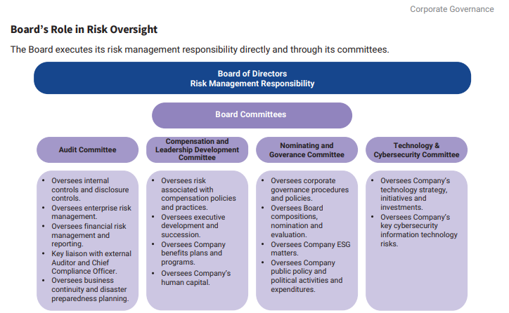

The Board and Its Committees There are four committees of the Board: the Audit Committee, the Compensation and Leadership Development Committee, the Nominating and Governance Committee, and the Technology and Cybersecurity Committee. The Board has delegated various responsibilities and authorities to these different committees, as described below and in the committee charters. The Board committees regularly report on their activities and actions to the full Board. Each member of the Audit Committee, Compensation Committee, Nominating and Governance Committee and the Technology and Cybersecurity Committee was appointed by the Board. Each of the Board committees has a written charter approved by the Board and the key committee charters are available on our website at investor.gendigital.com, by clicking on “Governance Documents,” under “Governance.” The following table shows the proposed composition of the Board and its committees, and other information, following the Annual Meeting. Current committee composition is provided in the text below the table.
